Calculus 3 Lecture 12.4: Velocity and Acceleration of Vector Functions
For a Vector function, 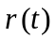
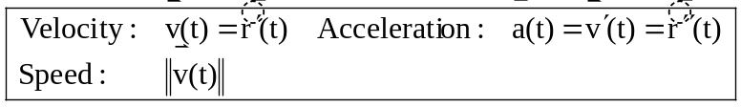

Example
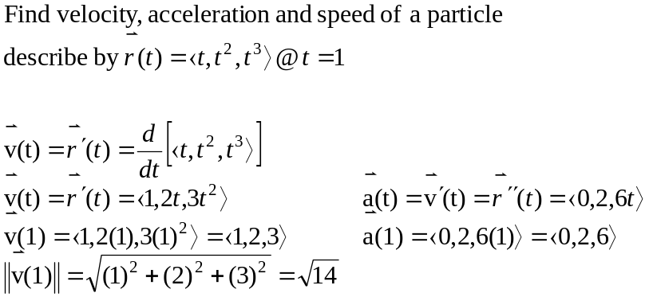

Example
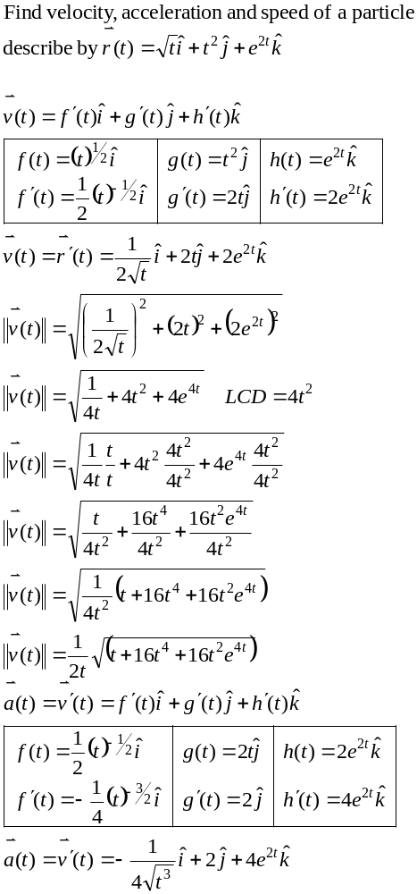

Example
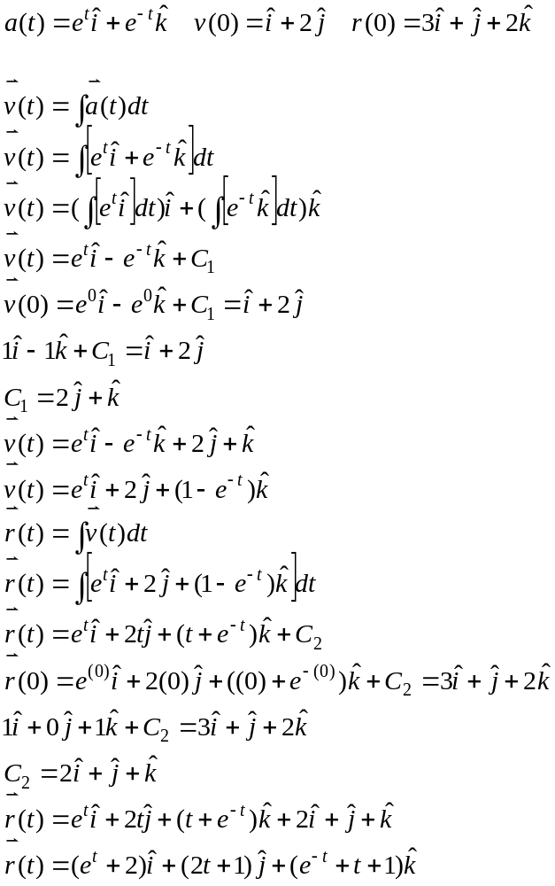

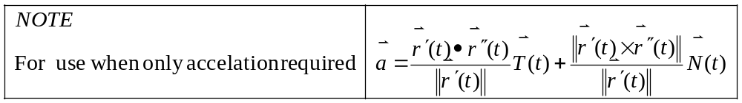

NOTE
We can define acceleration as a vector with 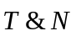
(Let 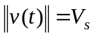 SPEED)
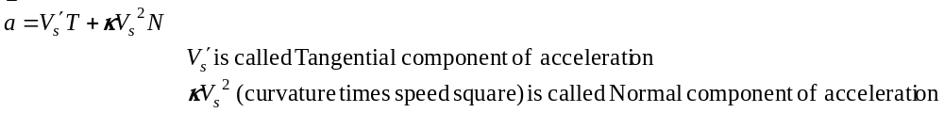

Projectile Motion:
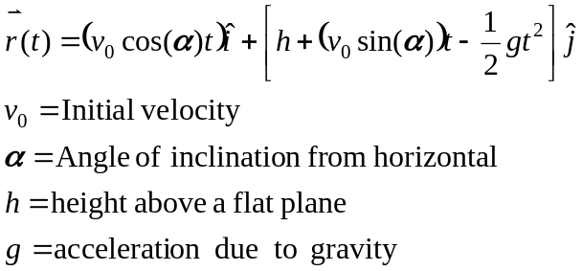

Example
You shoot a rifle from a 200ft cliff with an angle of 30 degrees
with a muzzle velocity of 1500 ft/sec

